Financial/ Investment Analysis
Walmart Inc.
Your name LNo and email address
Course number and title
Date/report submitted

Contents
I. Company Overview – Walmart 2
II. MD&A Summary 2
III. Summary of Horizontal Analysis: Income statement 3
IV. Summary of Vertical Analysis: 5
V. Investment Recommendation 7
Reference 7

- Executive Summary

Although Walmart’s ROI and ROA fell from 15.5% to 15.2% and 7.5% to 7.2% in the last 24 months, I would recommend investors to invest in the company nevertheless. This is because the company has shown tremendous growth rate in the period and its financial ratios show that it has the capacity to pay its short-term debts. The 40% equity shows just how stable the company is.
Background
The Walmart Company has shown a great growth potential over the last 36 months. For instance, in 2018, the company recorded excellent financial records by increasing their net sales by 5.9% to $443.9 billion. Moreover, its earning per share has been at $4.54. ROI and ROA fell from 15.5% to 15.2% and 7.5% to 7.2% in the last 24 months.
Discussion
From the figures, the Walmart Company experiences a reduction in its equity implying that its capacity to pay short-term debts has reduced over the last 36 months. Furthermore, ROA and ROI values have reduced showing that the company is reducing its capacity to earn revenue from less investment. This might imply that its competitors are gaining an advantage over it. However, there is hope since the company has been experiencing tremendous growth in its net sales. This shows that the business is increasingly growing and that investing it is guaranteed to yield positive results. Moreover, because of the Covid-19 pandemic, the business may gain more customers in the future due to increasing interest on groceries.

- Introduction
The objective of conducting this research has been to analyse the financial status of the Walmart Company and deduce from the findings if it is a viable form of investment. Therefore, the study will employee financial figures such as its sales, ROI and ROA among other figures to determine its standing in the market.
- Walmart Company Description
The Walmart Company is the leading grocery retailer and Toy Company in America controlling 20% of grocery based consumer goods and 45% of toys sales. Walton founded the company with the moto of creating value for the consumers to create satisfaction of the consumers in the service industry. By 1945, the Sam Walton with the support of his father had made the company a retail business and went to open the first retail store in Rogers, Arkansas in 1962. The company went on to be listed in the stock market by 1965. In 1990, the company earned its spot, as the top retailer but this did not satisfy Walton who wanted the company to have a wide global presence. Therefore, the company entered the global market with its entry in Mexico City and has from then expanded its presence within and without the US and other global markets in Europe and other continents.
Walmart’s mission reads, “We save people money so they can live better” while its strategy reads “Promote ownership of Walmart’s ethical culture to all stakeholder globally”. Its key source of functionalities include;
- The most significant contributions of its net sales comes from its retail stores in the US.
- The market segments out of the US are terms as Internation Walmart, consisting of supermarkets, retail businesses and clubs and forms the second biggest part of Walmart Inc.
- Sam's club is known to have the least percentage of net sales and operation costs.

- COMPETITOR ANALYSIS
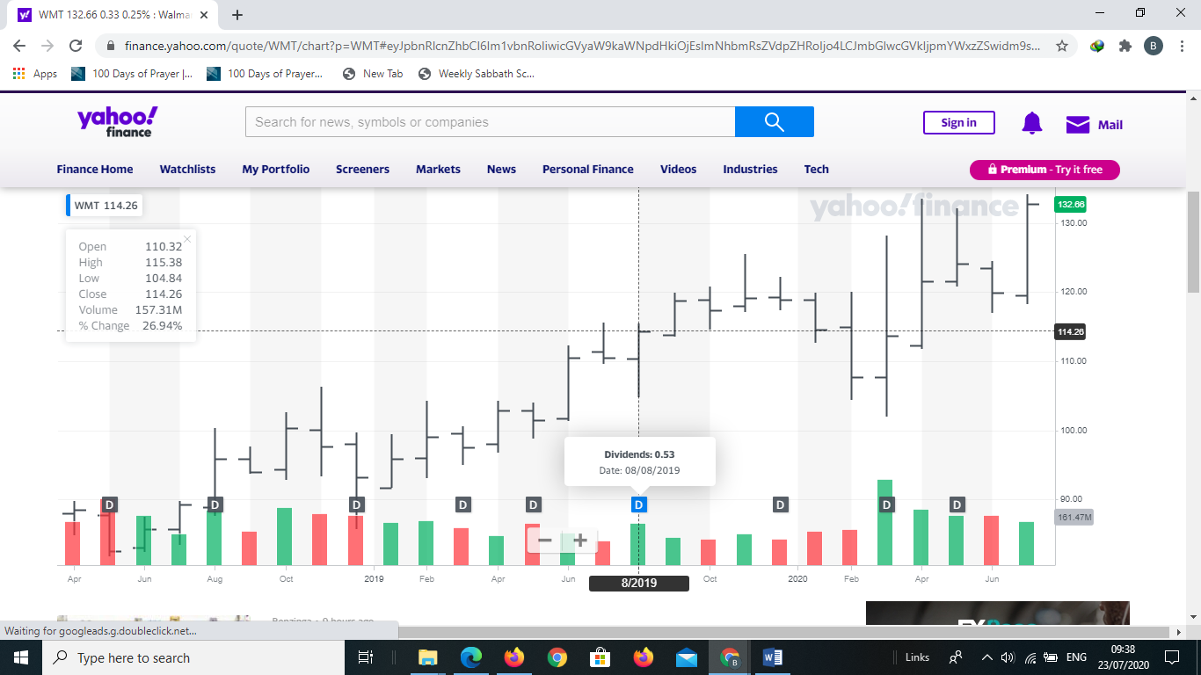
(Img source: yahoofinance)
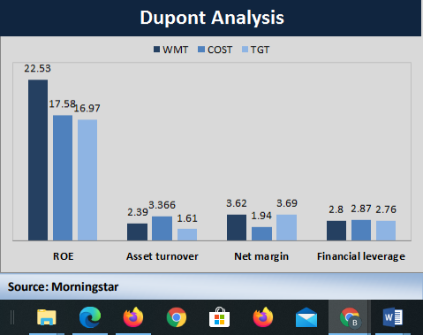
(Img source: Stone, 2013)

Figure 1: DuPont analysis

From the DuPont analysis, the company is seen to generate the highest ROE of 22.53 in highest financial ratio (2.8), net margin (3.62) and asset turnover of 2.39 in comparison to its biggest competitors Target and Costco (Stone, 2013).

From the competitive analysis, the company has opportunities of expanding to new markets (Jurevicius, 2013)
- Summary
The three factors that interest investors in a company include company growth, concepts of free cash flows and retail performance metrics
- RESULTS
Company Growth:
This section provides data on net sales of the company's three main sources of operations with percentages of each segment and changes over recent years.
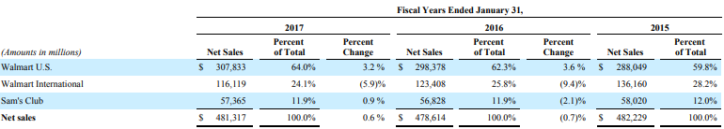

Investors will be interested in these numbers as it provides an overview of the company's sales in the three key segments over the last three years. As illustrated, Walmart Us always has the highest sales, followed by Walmart International and Sam's Club respectively. The information helps the investor make the right decision to invest in the appropriate segment of the company to match their budget and available resources. In addition, the investment decision will be affected by the growth of total net sales of the company over the years. As can be seen, although net sales in 2016 are down from 2015, it has grown back in 2017, going up from 418,674 to 481,317. Given the current difficult economic, financial situation, and the drastic price competition from other competitors, achieving such a growth rate will lead to positive thinking from the investors for Walmart.
- Returns: This category includes the calculation of returns on assets (ROA), return on investment (ROI.
The ROI and ROA analysis offer credible information on the business’ ability to generate returns from its assets/investment. However, calculation of the ROA value for different companies is dependent on the type of business/business sector. This explains the reasoning behind the need to compare the firm’s ROA with other firms ROA operating in the same industry over the same period. Business assets are obtained from loans and equity that are applied for financing its operations. Therefore, the ROA and ROI ratios influences the investors decision making since they understand that transfer of capital into profits is indicated by the ratios. Higher values of ROA implies that the firm is better able to create profits from less investment. For the Walmart Company, the ROI and ROA have been decreasing steadily over the last two years from 15.5% to 15.2% and 7.5% to 7.2%. The information is disturbing and may cause investors to reflect before considering investment in the company.
The cash flow refers to the measures of the business’ performance as calculated through the difference of the operating cash flow and the capital expenditures. Put simply, cash flow of the business reflects the money that the firm is capable of generating after it has left a portion of maintaining and expanding its assets for productions.
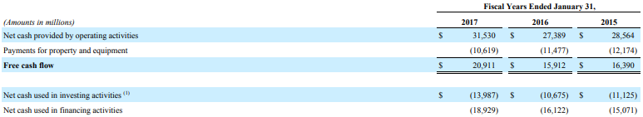
- The idea of free cash flows is vital since it permits firms to track investment opportunities with the capacity for maximizing values of their shareholders. Business find it extremely difficult to create new products, pay dividends, and make acquisitions and even repaying for their debts. Walmart has a free cash flow of $20.9 billion, $15.9 billion and $16.3 billion in 2017, 2016 and 2015 respectively. The increase implies that Walmart is improving its capital management capacity and thus attract investors through its growth.
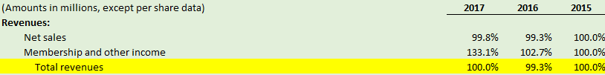
- Summary of Horizontal Analysis: Income statement
Walmart increased about 1% in the percentage of total revenue. This trend is important because it shows that the company is improving its sales situation by importing a few new products and maintaining the development of existing items. In addition, this increase also indicates that the income from members and other income went up over these two years, which may mean that cash received from members rose very lightly in 2017.

In spite of the rise in total revenue, the downward trend of net income distributable to Walmart implies an increase in the selling, operating, administrative, advertising expenses and cost of sales. This is important because it shows Walmart has one of the largest distribution systems in the world, which makes the company's operating costs likely to increase over the years.
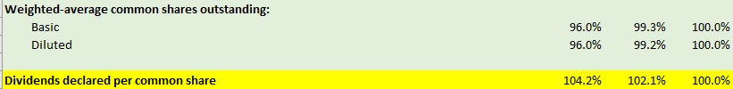

Potential investors may be attracted by the upside trend of the dividends declared per common share because it shows retained earnings after deducting the company's profit; and in the case of Walmart, dividends that shareholders receive at each common share they buy are growing around 2%.

- Summary of Vertical Analysis:
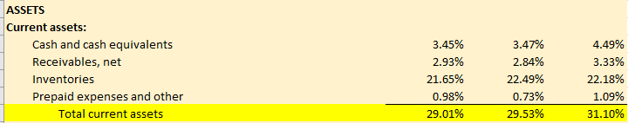
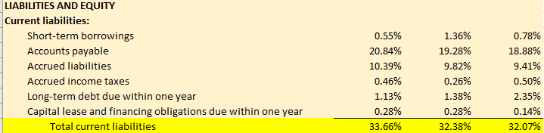
Some of the current assets are cash, accounts receivable, investments, available-for-sale securities, prepaid expenses or other liquid assets. Current assets are very because they are the assets used in the daily operating fund and cover the costs incurred. Compared with total assets, the current assets of the company are maintaining a percentage of about 30% over the years. This suggests that the short-term source of the company's short-term debt is unchanged

This refers to the debt that is determined in a fiscal year. They include items like bills payable that demand for payment within short period like one year. Tendencies of current liabilities are exceptionally vital since the business utilizes cash for short-term assets in paying the short-term debts. As has been depicted in the diagram, the current liabilities of the Walmart company has been increasing in the last two years with stability in current assets as illustrated showing that Walmart’s ability to pay short terms debts is decreasing
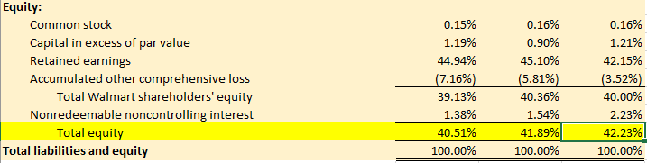
The rate of equity is about 40% and does not seem to change over the years. This indicates that the company is maintaining a balanced ratio of debt and equity (6: 4); and this ratio demonstrates Walmart is more of a service company than a production company is. This trend is necessary since it gives a picture of the financial structure of the firm, financial strengths and how it pays for its operations
Summary of Ratio Analysis
Liquidity Ratios
Current ratio of Walmart fell in 2017 compared to 2016. A ratio of 0.86 implies that for each dollar of current liabilities, Walmart has $0.86 of current assets. Both its 2017 and 2016 ratios are lower than industry and Costco’s current ratio of 0.97 and 0.99 respectively; this company does not have enough current assets to pay its current liabilities
The 2017 Acid-test ratio of 0.19 shows that for each dollar in current liabilities, Walmart has $ 0.19 of highly liquid current assets. This ratio increased slightly from 2016. It is very small compared to the current ratio, which means that the company has a large inventory of assets. This ratio is smaller than that of the industry and Costco.
Walmart's receivables turn over 82.9 times a year. The faster receivable are collected, the better the company is able to assess the liquidity. Therefore, the evaluation of liquidity is better than the industry but worse than Costco. This proves that Walmart has less sales on the account and more sales through cash, which is the opposite of Industry.
Walmart turns over its entire inventory 8.3 times a year. Its inventory turnover decreased lightly between 2017 and 2016. The turnover ratio of company is lower compared with that Costco’s turnover of 11.9 times.
In general, liquidity of Walmart is comparable to that of the industry but slightly lower than that of its direct competitor Costco.

Solvency Ratios
Walmart’s debt to total assets ratio 0.59 confirms that creditors have provided 56% of Walmart’s total assets. It stayed unchanged between 2017 and 2016, but both are smaller than the ratio of Industry and Costco
In 2017, Walmart had free cash flow of around $17,543 million to invest in additional PP&E, repay debt and shareholder dividends. This number is up from 2016 and much larger than Costco’s and the industries.
From a general perspective, the solvency ratio of Walmart is better than that of competitors and industry because it has a lower rate of debt to total assets and a higher number of free cash flows.
Profitability Ratios
The gross profit margin of 24.9% indicates that for each dollar of sales, Walmart generate $0.249 of gross profit. This percentage is higher than Costco and lower than the Industry.
Profit margin of 2.8% means that the company generated 0.28$ profit for every each dollar of net sales. High-volume business like Walmart normally have a low profit margin. This ratio did not have much difference compared to industry and competitors.
Walmart had asset turnover of 2.4 in both years, which means that each dollar it invested in assets, the company will generate 2 for sales. This number is equal to the Industry and is smaller than Costco.

- Recommendation
Investors should invest in this retail company as development indicators as well as returns provide a positive view of the company. Despite the negative trends in recent years, these phenomenon are not significant compared to Industry and other competitors. In my opinion, investing in Walmart is entirely possible. However, investors should also consider carefully before making a decision, it should be consistent with their budget and business purposes.
Moreover, Walmart develops great workplace environment for its employees that is very competitive to offer self-improvement and respect to the employees. I therefore believe that it is wise to seek employment in the company

- Conclusion
This analysis assessed the Walmart's performance, competitor analysis, history, and the way the business has executed its strategies and objectives. From the study, Walmart's low cost strategy attracts more consumers thereby increasing its profit margins. Moreover, Walmart satisfies its consumers’ needs by providing them with a variety of products thus reducing its risks of customer turnover. It is therefore well positioned and has the capacity of controlling the market share thus explaining the success with which it expands to global markets.

Reference
Jurevicius, O., (2013). SWOT analysis of Walmart. Retrieved from, http://www.strategicmanagementinsight.com/swot-analyses/walmart-swot-analysis.html
Our story. (2017). Retrieved from https://corporate.walmart.com/our-story/our-history
Stone, B., 2013. Wal-Mart: Future Looks Bright. Retrieved from, http://seekingalpha.com/article/1874691-wal-mart-future-looks-bright
Walmart, (2019). Our Story. Retrieved from, http://corporate.walmart.com/our-story/
Walmart, (2019). Walmart announces FY2013 global capital expenditure program of $13 to $14 billion; Company sets five-year commitment for greater operating expense leverage. Retrieved from http://news.walmart.com/news-archive/investors/walmart-announces-fy2013-global-capital-expenditure-program-of-13-to-14-billion-company-sets-five-year-commitment-for-greater-operating-expense-leverage-1616558

